Basic Steps to use Wireshark for the understanding of Network traffic, Scanning and Monitoring of various packets.

1. Click on the Wireshark Legacy icon

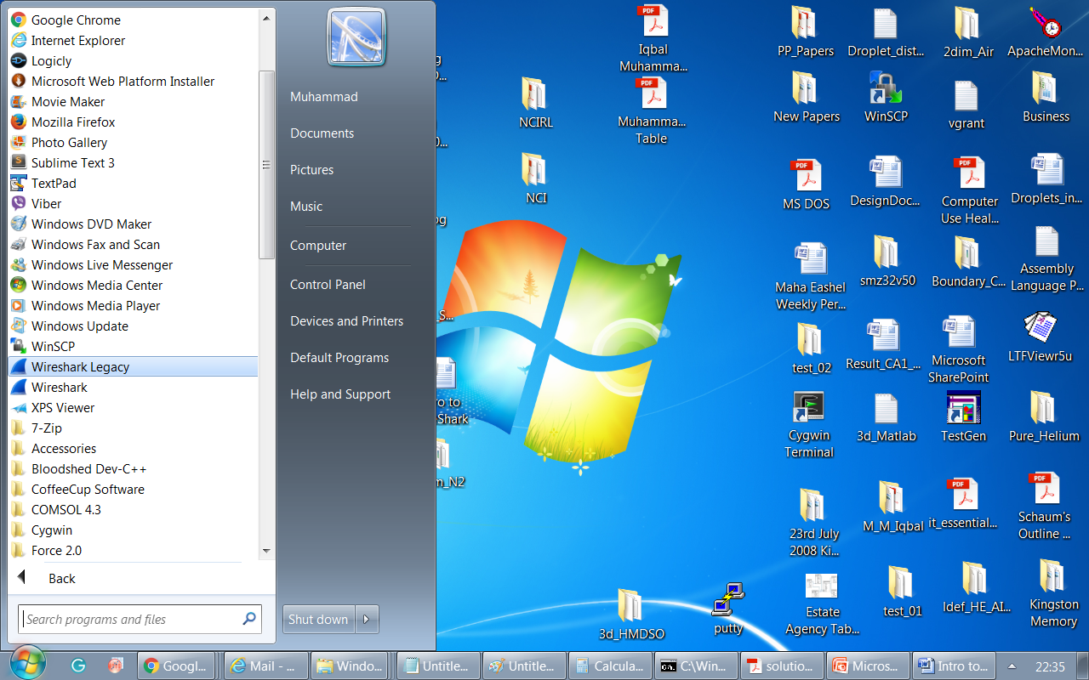

1. This window is opened as

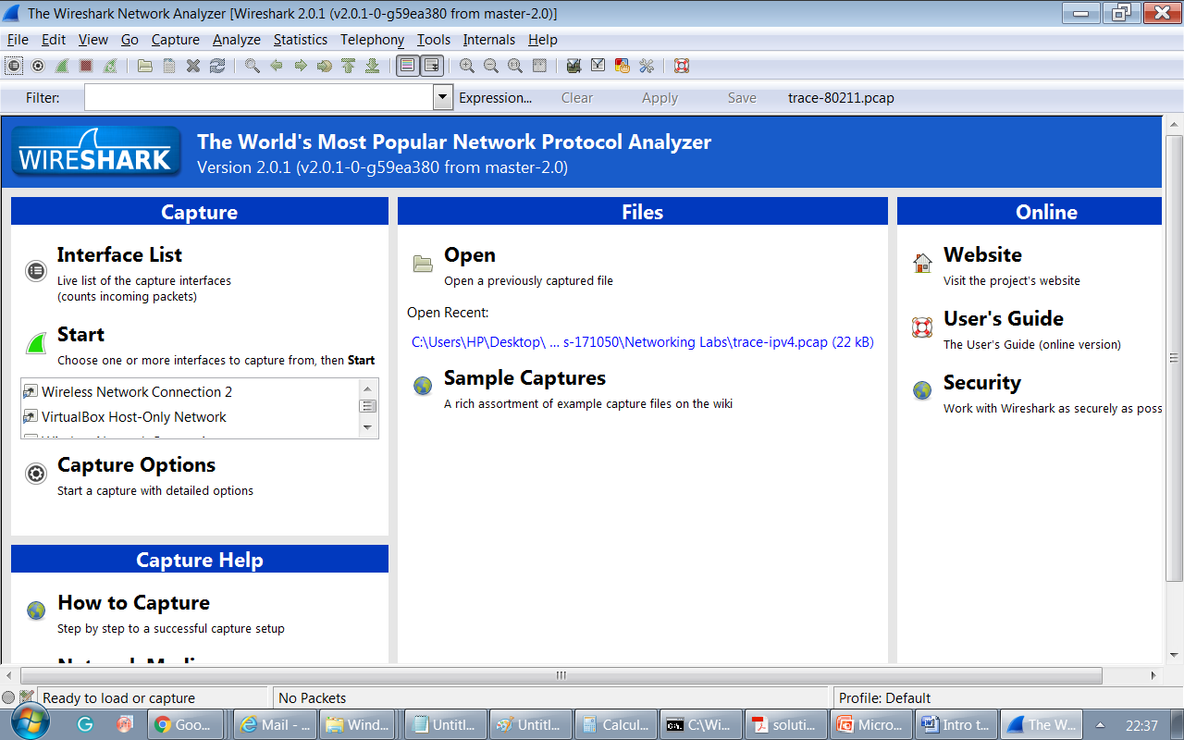

1. Click on the Interface List pointed with a red dotted arrow as

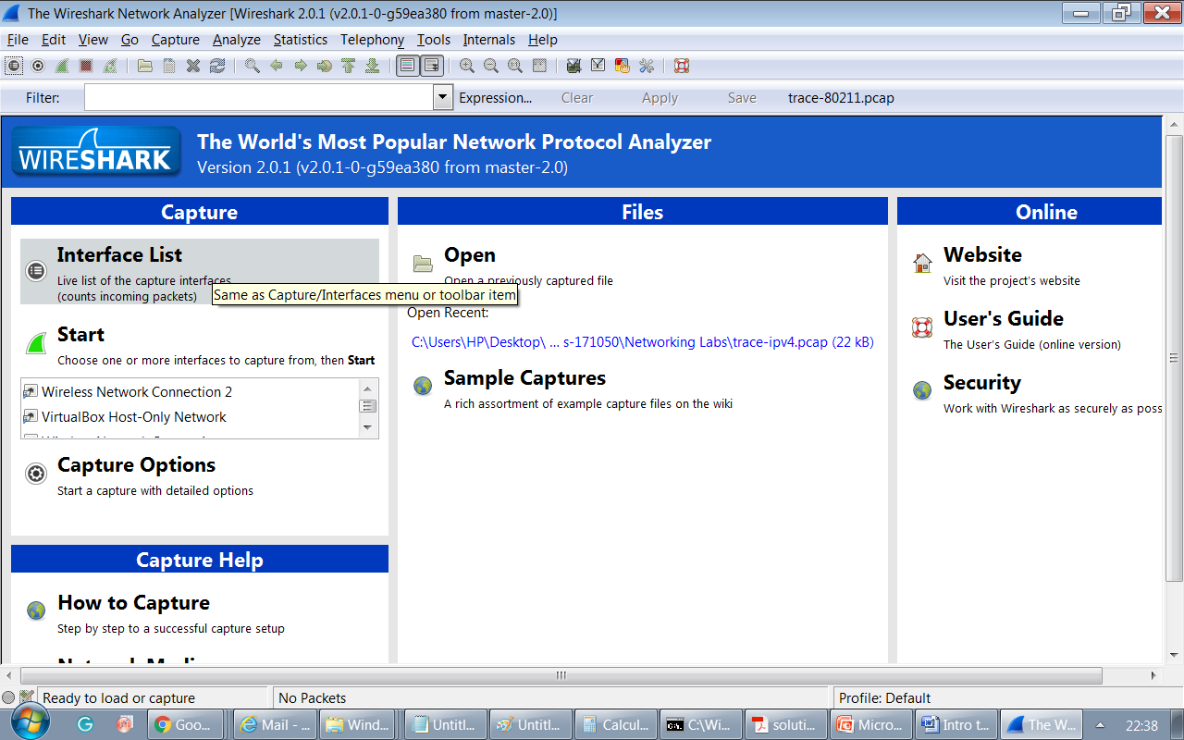

1. Select the network for the connection

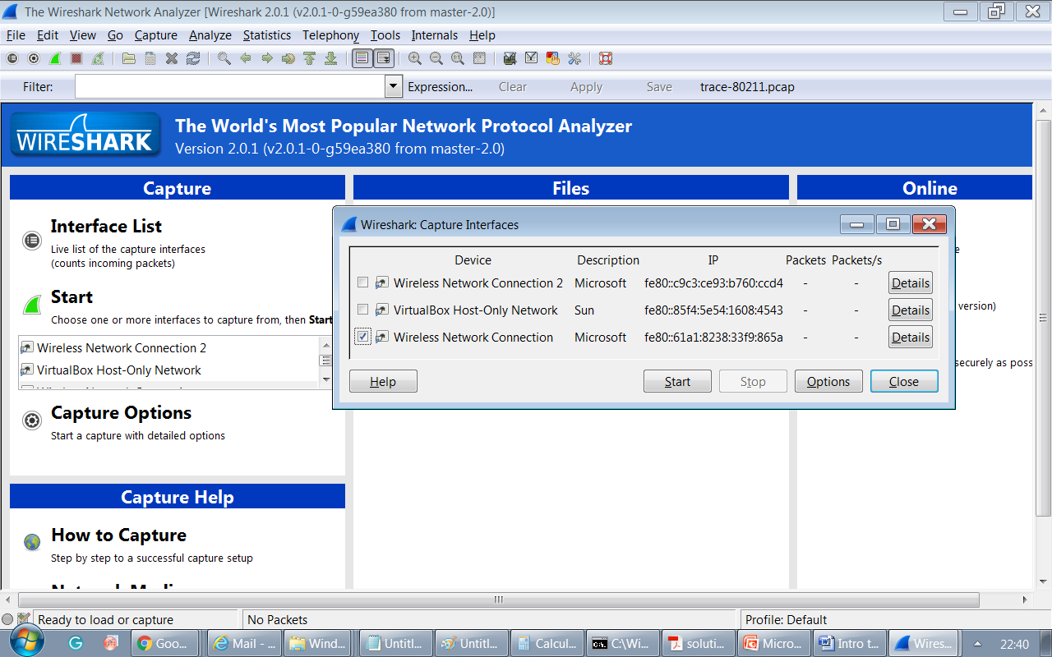

1. Click on the start button to move forward
2. A window with significant network traffic will appear as

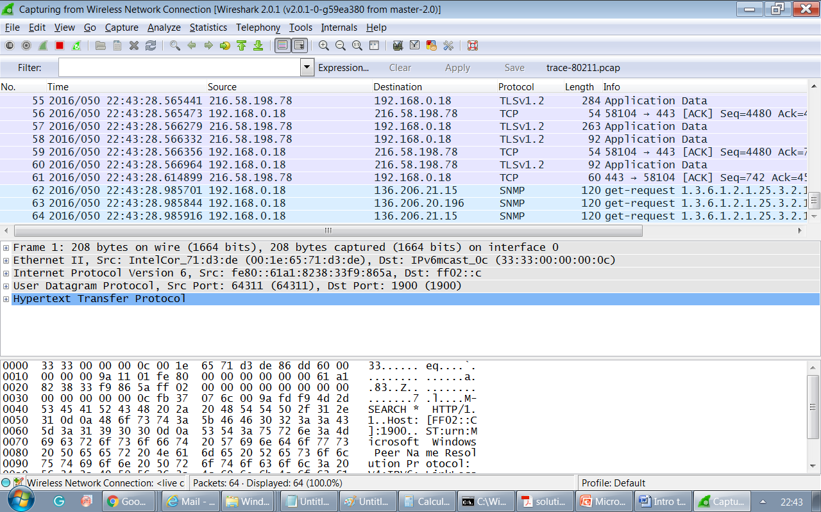

You can start the scanning of network with source, destination addresses, Protocol, length and information about the packet frames.

1. The live traffic can be stopped by clicking on the red “Stop” square button.

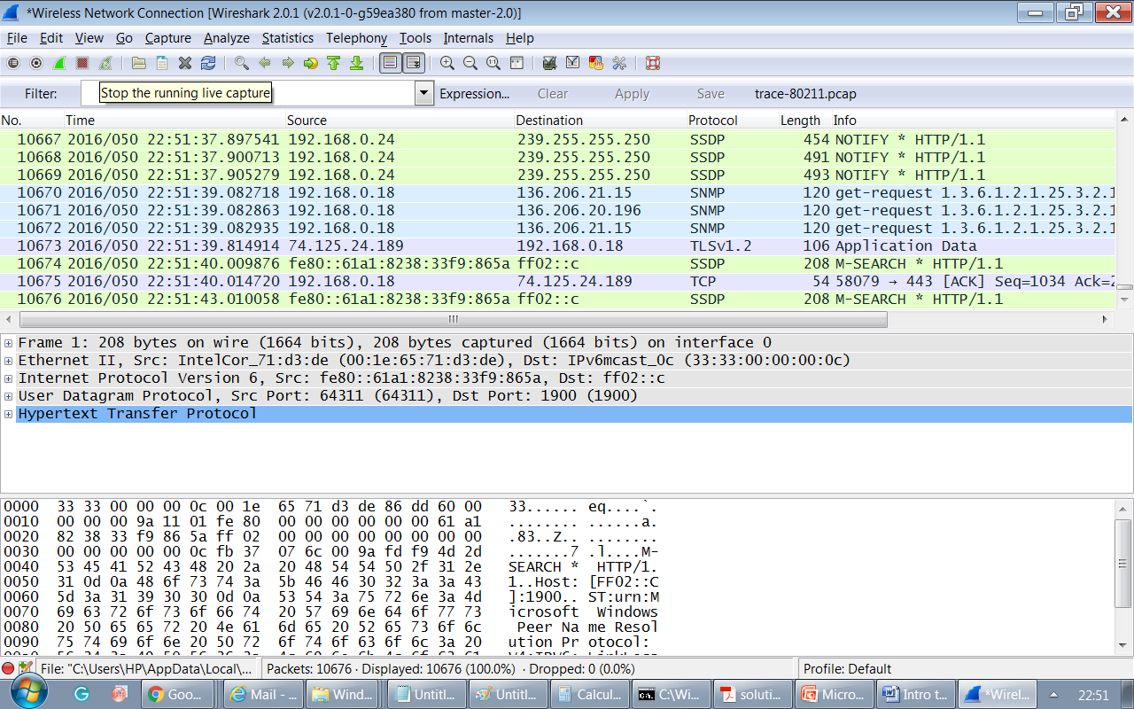

1. The traffic can be filtered by introducing a keyword in the mentioned box pointed with an arrow

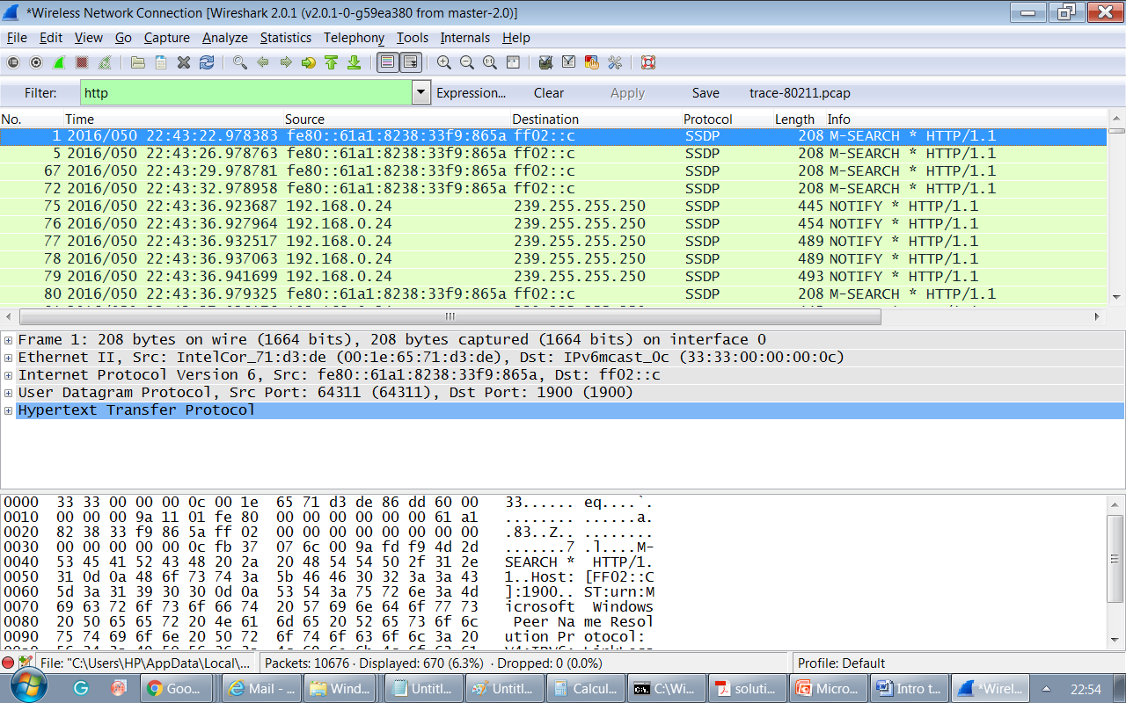

1. The detailed information about any packet frame is available by double clicking on the source/ destination address

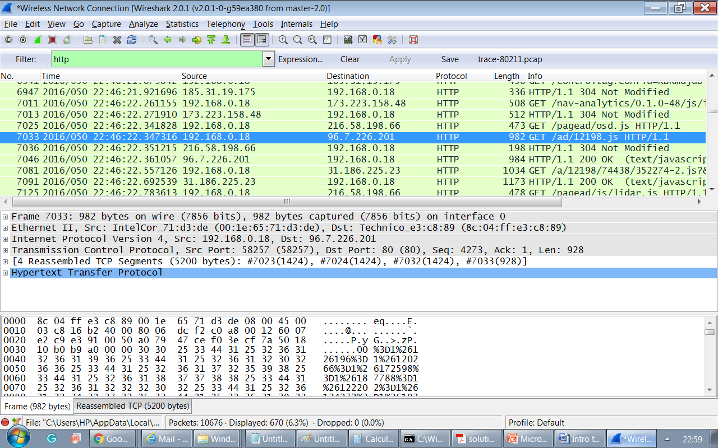

1. If you want to save the session, then the following alert will appear by pressing the green button

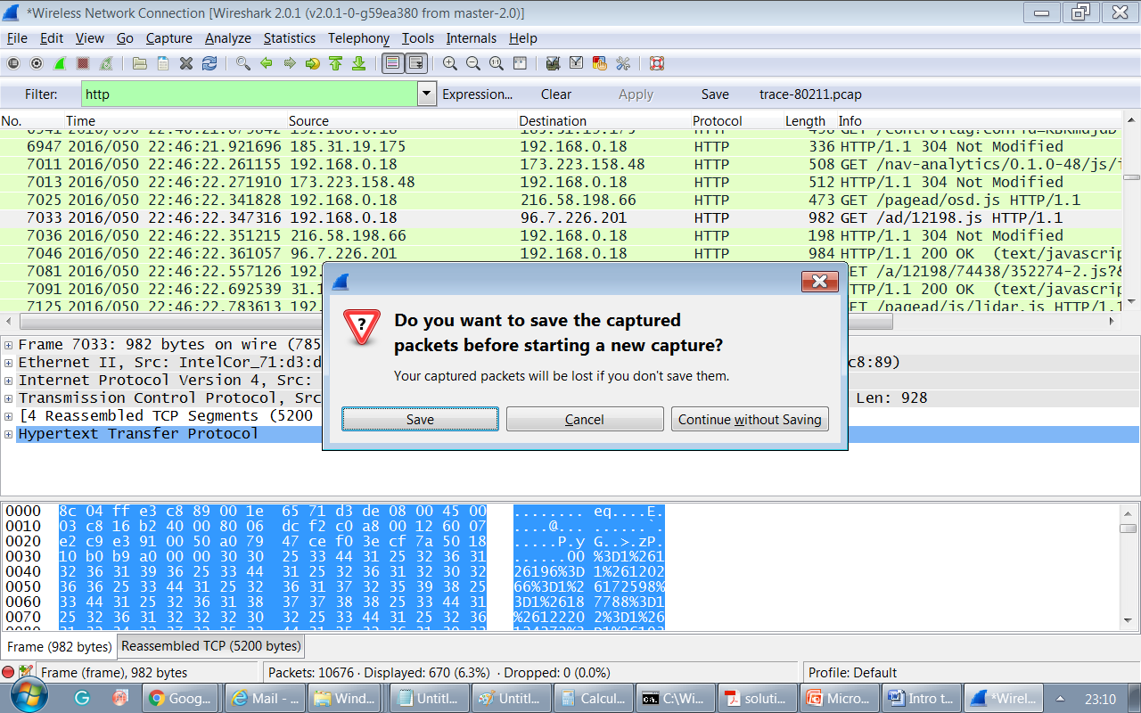

1. If you know the IP address of source/destination, you can get the details of hypertext transfer protocol.

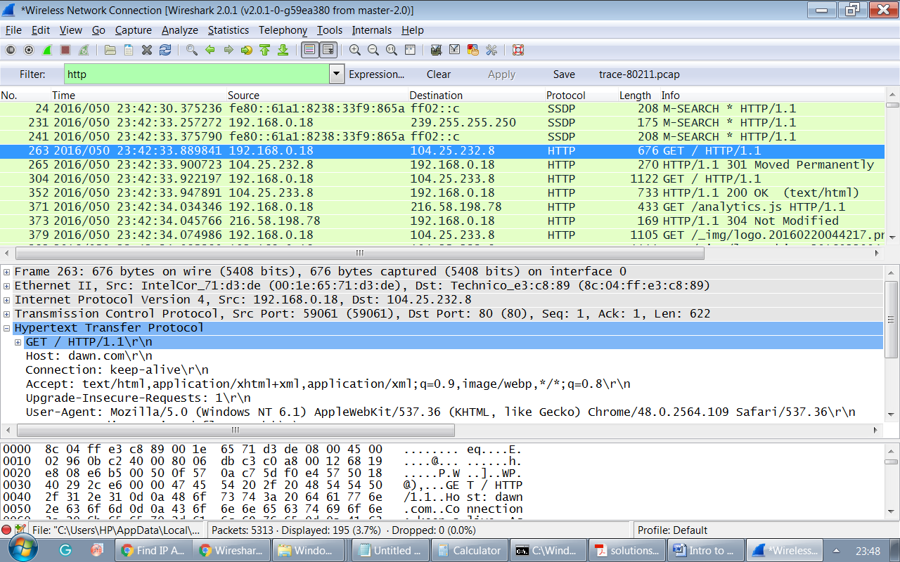

1. You can link this with the filter to know the details of packets of any particular source/ destination.

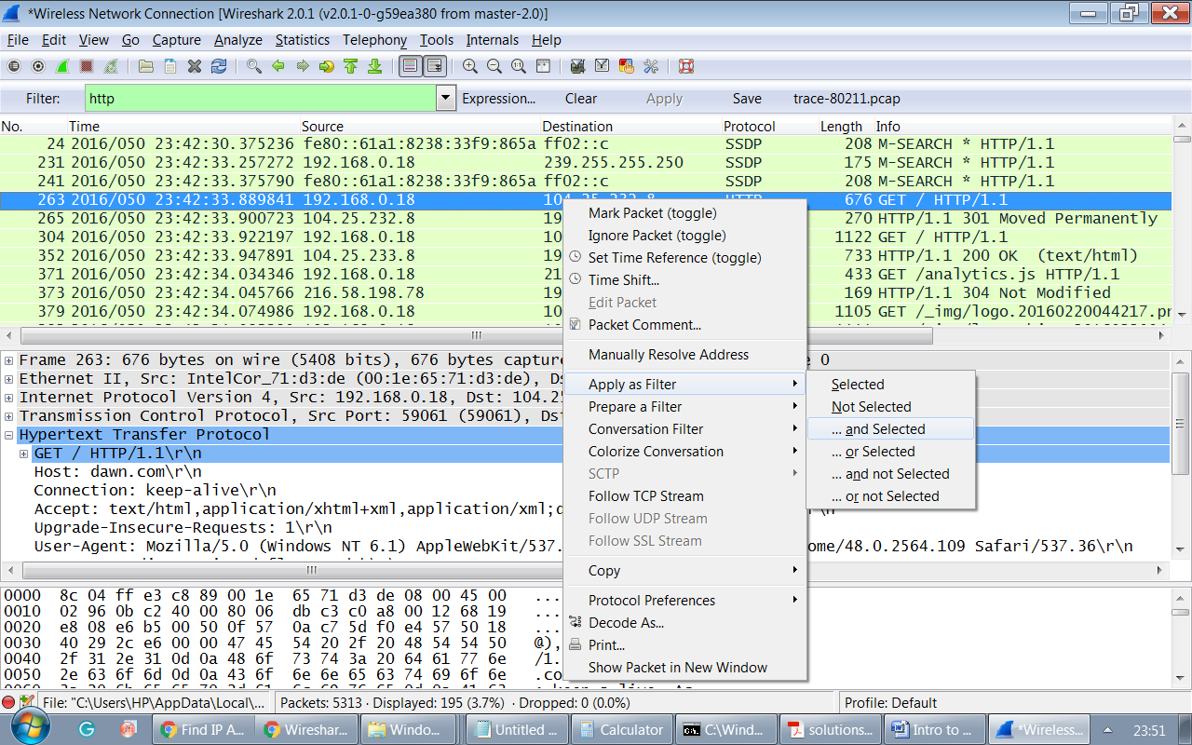

1. The resulting window will appear as

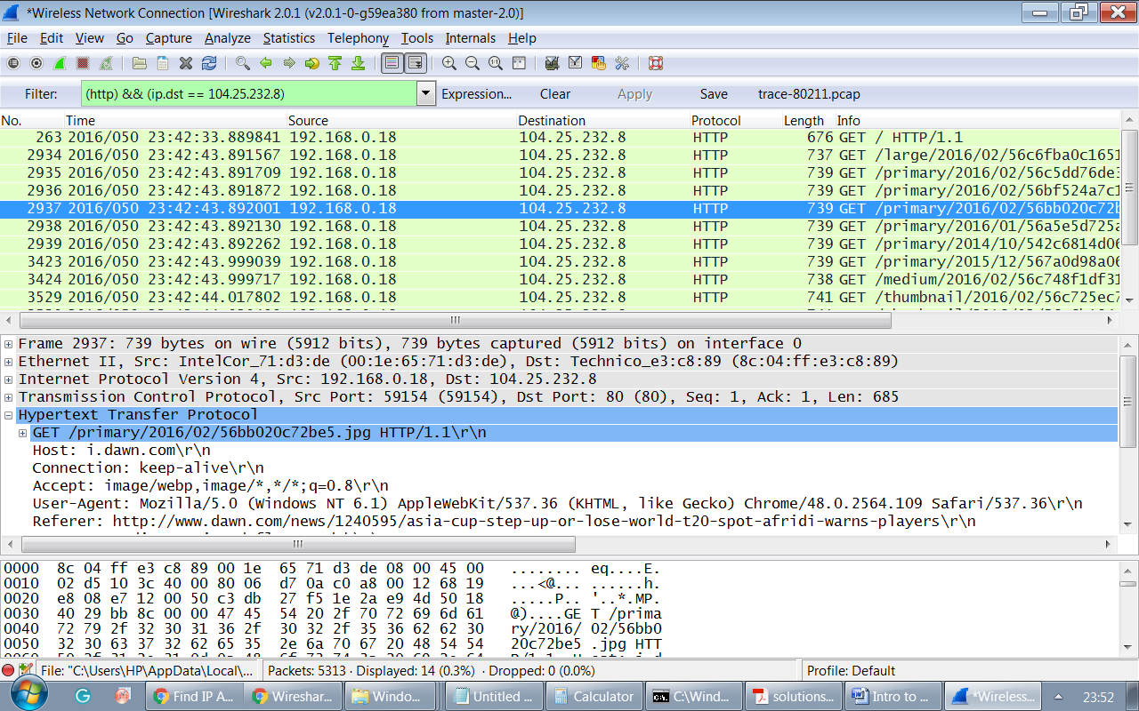

If you still need to explore the Wireshark for the analysis of network traffic, watch the video at the mentioned address below as

<https://www.youtube.com/watch?v=TkCSr30UojM>